**DAM PROJECT**

**PROJECT PROPOSAL**

|  |  |
| --- | --- |
| Verbat Logo | Client Logo |

Submitted by

**VERBAT TECHNOLOGIES**

**Billing Entity: Verbat Technologies Pvt Ltd**

Dated

**Wednesday, 12 April** **2018**

C:\Users\Prince\Downloads\Desktop\Untitled-2.pngProposal Brief  

# Document Details

|  |  |
| --- | --- |
| **Reference Number** | SM-SG-1610-008 |
| **Project Name** | DAM PROJECT |
| **Project Category** | Development |
| **Proposal Date** | Thursday, 12 April 2018 |
| **Proposal Validity** | 90 days |
| **Submitted to** | Client |
| **Requested by** | Client |
| **Confirmed & Approved by** | Ayyam Perumal |

Contents

Document Details 1

Executive Summary 5

Introduction 5

Overview 5

High Level Architecture 6

Digital Asset Management (DAM) 7

Overview 7

1. DAM Admin 7

2. DAM Sites 7

Objectives 7

Scope of Work 8

1. Upload the asset file 8

2. Edit the asset file 8

3. Collaborate, access and share 9

4. Cataloguing Made Easy 9

5. Other Core Features 9

Risk / Assumptions / Limitations 12

Project Management Overview 13

Project Management Team 14

Notice to Proceed 15

Planning Phase 15

Master Program Review 16

Project Activities 17

Project Methodology 17

Planning and tracking 17

Development and Factory Acceptance 18

Service Delivery Model 20

Key Differentiators 21

Project Governance Responsibility Table 22

Roles and Responsibilities 22

Information on Training (Training to Trainers) 26

Training strategy 26

Plan 26

Training delivery methods 27

Train the Trainer: 28

Creating a training program 29

Responsibilities 30

VERBAT 30

CLIENT 30

Team communication structure 31

Acceptance Criteria 32

Service & Maintenance 33

Service Options Available 33

Response Times 33

Support Service Level Options Available 33

Escalation Process 34

Warranty 35

High Level Project Plan 36

Project Costing 37

Payment Terms 38

What’s Next? 39

Other Tools and Technologies 40

COTS/Software components/Others 41

Contact Details 42

C:\Users\Prince\Downloads\Desktop\Untitled-2.pngRestrictions

This data shall not be disclosed and shall not be duplicated, used, or disclosed in whole or in part for any purpose. If a contract is awarded to as a result of or in connection with the submission of this data, the client or prospective client shall have the right to duplicate, use, or disclose this data to the extent provided in the contract. This restriction does not limit the client’s or prospective client’s right to use the information contained in the data if it is obtained from another source without restriction.

# C:\Users\Prince\Downloads\Desktop\Untitled-2.pngExecutive Summary

## Introduction

Client has raised the RFQ to manage Digital Asset Management System (DAMS) in the .net. This document provides a comprehensive custom/development plan and proposed solution.

## Overview

CLIENT would like to implement an On-Site Digital Asset Management System. Digital assets are any form of a digital file. Common digital assets include images, documents, photos, presentations and videos.

Digital asset management (DAM) offers an effective solution for enterprises to store, organize, find, retrieve and share digital files. Quick to deploy and easy-to-use, a centralized digital library provides peers, employees, clients, contractors and any other key stakeholders controlled access to digital assets — including images, photos, creative files, video, audio, presentations, documents and more.

Digital asset management software is primarily used by enterprise marketing and creative teams, so it is necessary for DAM software to accommodate a broad spectrum of creative files.

# C:\Users\Prince\Downloads\Desktop\Untitled-2.pngHigh Level Architecture

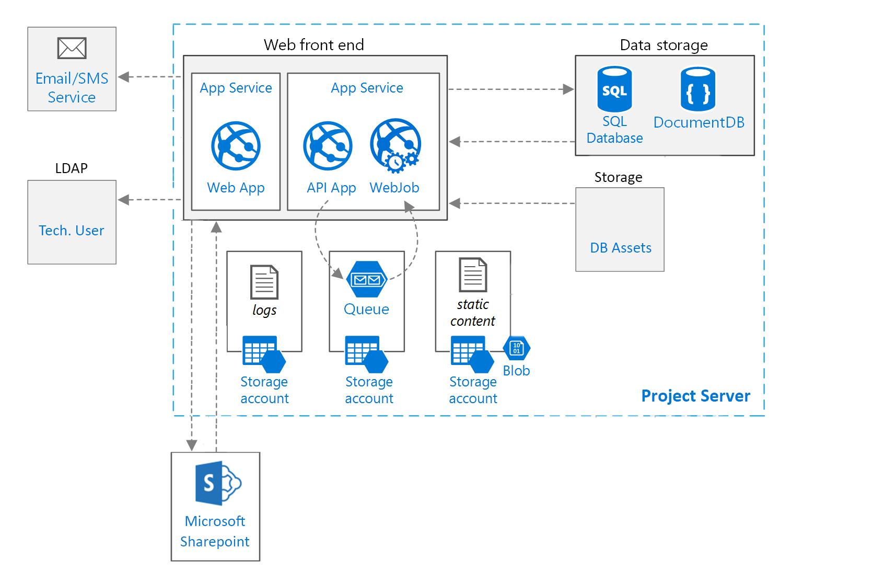

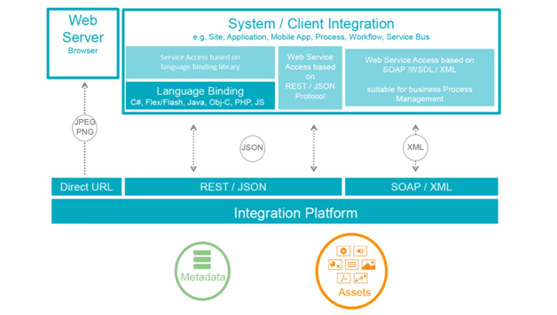

# C:\Users\Prince\Downloads\Desktop\Untitled-2.pngDigital Asset Management (DAM)

## Overview

Verbat proposes a .net custom solution based approach for development of DAM system. The following key features are requested as per Functional Requirements.

Verbat would recommend the following high level functional architecture for Verbat. Due to the complexity of the requested system, Verbat have used the best possible technology to be most cost effective as well.

The architecture is a combination of .net, scripting and other peripheral tools to deliver the system as requested in the RFP.

The application is mainly categorised based on the user group. There are two main categories are listed below.

1. DAM Admin

The DAM Admin application is mainly meant for the administrators users who can configure the DAM application according their site preferences. This is highly configurable modules which controls the entire site application behaviour. Some of the main functionality includes in this is listed below.

* 1. Backup Manager
  2. Mail Manager
  3. Report Manager
  4. User Manager
  5. Web Client Configuration

1. DAM Sites

DAM Sites application is meant for the users who can perform the activities like Upload, View, and Share, Download and Print on the digital assets.

## Objectives

1. The DAM Sites user can login into the application and perform the below set of activities.
2. The administrator can set the catalogs permission on which the DAM Sites user can do perform the above activities.
3. The user can create a collection and share the media asset to the users, which can be later used to download and print in many options.

## Scope of Work

There three main core functions the system is meant to perform the first function is to upload the second is to edit for search ability and the third is to share and repurpose.

### Upload Asset Files

1. The first way is user can click open this asset folder and select one or always assets and hit OK.
2. The other way is user can scroll out of the same folder drag them on the upload.
3. Then it automatically extracts the related metadata associated with the uploaded file.

### Edit Asset File

1. When the user searches and select an asset to edit the application will automatically extracts the related metadata associated with this record now this is out of the box but this can be configured and customized to meet the specific needs.
2. We have the file format the height the width the resolution.
3. The user can create a container where he can group the assets, it’s not making a copy of this assets rather referencing this record or asset in multiple containers. So any time there’s a change make like a new version or there’s been some additional metadata has been updated it’s going to update that record anywhere in the system it lives.
4. The user can add Key words for improve search ability, author, star rating etc.
5. In the application we have other tabs like relation, history and comments.
6. **Relation Tab**

Usage – The user can create and find groups of files that coexist like a PowerPoint with multiple images and slides. The user can group those records with a master file and find with one click.

1. **Comments Tab**

From the comments tab, when the user can create a string of comments for people within the system asking them to do certain things or actions like look at a file make changes to file and reply back to me. The user can also make comments directly on the preview itself so to make a comment direct into preview and select a specific area I want someone to take a look at make changes.

1. **History Tab**

When the user checks out the selected picture and opens in Photoshop and changes this image and click to save the changes. And then check this record back and the user receive the notification. Now the user can view the edited record along with the original record under the history tab.

### Collaborate, access and share

Share any folder or collection with your group in a public space or within organization. With the commenting and discussion feature you can give appropriate feedback for each asset.

You can let users look at your assets with sharing a folder or collection. You can assign permissions to allow downloading of assets or enable the ordering option.

Three ways the user can share the files are listed below.

* 1. Create a collection for personal use only
  2. Share the collection within the application user
  3. Send a link to the collection to selected recipients

The user can enter the recipient email address and then if they are integrated in the active directory they will auto complete.

The user can input the details like.

1. Subject Field
2. Add Text
3. Set an Embargo Date – When the user wants this collection to go out.
4. Expiration Date

### Cataloguing Made Easy

The application can be integrated into your publishing workflow and captures, displays and writes metadata (XMP/ITPC/EXIF, etc.). This way you can add keywords and description that travel with your assets. It now also captures all metadata from different documents, videos and audio files.

To make information consistent across your media library it uses the XMP standard. XMP is a open standard that is being used by all major vendors.

### Other Core Features

#### Single Sign on (SSO)

Drag assets directly from your desktop to the upload window. You can also select many assets in one go. This can also add files from your FTP server, by eMail or create a link to your existing file server.

#### Supports all well-Known file formats

The application lets you manage and publish digital assets independently from any format. We support video, images, audio and many more file formats. Manage and access all your digital media assets in one location at any time.

Images, Videos and Audios can be individually converted to other formats. This allows you to deliver the correct content to the right device on the fly. Pass on direct URLs to your customers and/or generate a public webpage with a collection of assets.

#### SharePoint Integration

Optional integration into SharePoint is available using the SharePoint Object API. Also, the application lets you access your digital library directly.

#### Dynamic filtering

This application not only stores your digital assets but also search and find them again. The application searches the title or description of your documents along with full index search of the whole document. We even take it one step further and index available metadata within your assets.

#### Image and video editing

The batch processing allows you to edit metadata of many assets in a single process. Furthermore, you can batch the encoding to many formats for a file in one step.

#### Privileges

It makes it easy to define access control for each folder. The group permissions puts you in control who can access your sensitive information. Users only see the folders and collection that they should see. Offer tools for managing rights and permissions of media content for external use and embedding on internal or external websites

#### Bulk editing of media

The batch processing allows you to edit metadata of many assets in a single process. Furthermore, you can batch the encoding to many formats for a file in one step.

#### Statistics and Reporting

The main purpose of a DAM application is to bring simplicity to storing, managing and sharing digital assets, the most innovative solutions also provide insights and information that is valuable to your business and answer questions like:

* What edits were made to metadata and by whom?
* Who logged in last week and when?
* How many times are assets downloaded, viewed, shared and repurposed?

The reporting features enable organization groups to understand how their digital assets are being managed and how they’re performing.

#### Preview of media files

Previews of media are handy because they can save you time as you don’t need to download a file to view it. Previews are especially important if you are working with extremely large files, such as videos and TIFF files that can take a few minutes to download.

#### Version management

Optionally you can create a new asset of your original asset and upload it as a new version. You can specify how many versions you would like it to keep. A list of all the versions lets you revert to a selected version.

#### Auto-tagging

The application automatically extracts file metadata and allows you to specify and enforce required metadata fields as assets are added. Creates its own custom keyword taxonomy or allow it to grow organically with your team. You can even add short and long descriptions and metadata in different languages.

#### Encryption

Security is even more important. External users should trust the content they put into the Digital Asset Management system. Likewise it should be protected by using protocols like HTTPS and other encryption methods.

#### Multilingual (Arabic is Mandatory)

The digital asset management system must provide full multi-language support. There are different levels to multi-language support.

* **Software UI in different languages**

Most users prefer working with a graphical user interface localized in their native language.

* **Localized metadata description**

A Arabic user might not know the labels in the application is. Therefore, it must be possible to translate the name of metadata fields, too.

* **Metadata in multiple languages**

The final element in a truly multi-language solution is support for maintaining metadata in different languages.

#### API/Developer access

Developers are free to use our API and integrate into their custom solutions for enhanced productivity.

#### Automatic thumbnail conversion

When you add assets it can automatically create thumbnails, poster images and playable audio files of your original asset.

#### Scalability

Given the exponential growth and demand for digital media, we know that the volume of content you have is only going to grow. We can also expect that the file sizes of your digital assets will increase due to continuing advances in camera resolutions and media production technology. And, the fact that anyone can create quality content with their smartphone today just means that the pace at which digital media is produced is just going to pick up.

This means that your DAM needs to be scalable to ensure your long-term success by allowing your digital library to grow and evolve as necessary. Our solution easily holds millions of assets in a single system with no maximum on capacity to accommodate your growing library of digital content.

#### Backup & Availability

With this option you get our backup solution with your server. Adding an additional backup plan to your storage gives you the safety that your data is safe, since your data is stored at different locations. Historic backup services automatically backup up your data in historic snap shots at time intervals that you can choose. With this solution, you can choose to backup weekly, monthly, or quarterly.

#### Functional Requirements

|  |
| --- |
| **Module** |
| **Initiation** |
| Business analysis |
| Project Management |
| Design and Prototype |
| **Development** |
| Application basic setup |
| **DAM Admin Modules** |
| Login, Forgot password |
| Backup Manager |
| Mail Manager |
| Report Manager |
| User Manager |
| Web Client Configuration |
| Dashboard |
| **DAM Sites Module** |
| Login, Forgot password |
| Dashboard |
| Information |
| Relation |
| History |
| Comments |
| **Actions** |
| Preview |
| Download |
| Share |
| Add to basket |
| Edit |
| Check In |
| Check Out |
| Delete |
| **DAM Clients** |
| Login, Forgot password |
| Dashboard |
| **Actions** |
| Download |
| Print |
| **General application features** |
| Simple search & advanced search |
| Send Feedback |
| dashboard for staff, receptionist, admins (Fav, Viewed, History, Shared, recommended excersises, Excersice charts etc.) |
| Intranet Manual |
| **System features** |
| Single Sign on (SSO) |
| Supports all well-Known file formats |
| SharePoint Integration |
| Dynamic filtering |
| Image and video editing |
| Bulk editing of media |
| Statistics and Reporting |
| Preview of media files |
| Version management |
| Auto-tagging |
| Encryption |
| Multilingual |
| API/Developer access |
| Automatic thumbnail conversion |
| Create a Collection and Sharing |

# C:\Users\Prince\Downloads\Desktop\Untitled-2.pngRisk / Assumptions / Limitations

**This needs to further discussed with Client and any complication arising of will be dealt on a fair basis for re-estimation**

1. The whole responsibility of data security is expected to own by Client.
2. The performance of the server and its configuration must be taken care by Client.

# C:\Users\Prince\Downloads\Desktop\Untitled-2.pngProject Management Overview

VERBAT is glad to have the opportunity to participate in the project for CLIENT. We have provided below our proposed project delivery methodology for the successful project implementation including all related works such as system designs, training.

**Agenda Alignment:** VERBAT will facilitate the development of all goals and objectives and then document for all team members namely representatives from

* CLIENT
* VERBAT

**Process Management:** VERBAT will establish the Systems, Execution Plans and Schedules to achieve the project objectives. In this way, VERBAT will assure that the tools are in place to achieve success and measure performance during the execution phase of the project. VERBAT will verify to ensure that all processes are executed to the approved methodology.

**Project Management:** VERBAT will execute the long term, short term, and day-to-day tasks associated with the project to assure that we are able to achieve the spelled objectives. In addition, VERBAT offers tangible benefits in the following areas:

Single Point of Responsibility for all project aspects – The nominated Project Director representing VERBAT will be the single point of contact for ease of understanding and control.

Overall co-ordination of the project up to personnel training for operation and maintenance – This will normally become tangible benefits to CLIENT (or partner as we prefer to call our clients) in the form of shorter response time, higher accuracy and better customer services.

Consistent management and performance as executed through VERBAT standard procedures – VERBAT believes in consistent update and feedback from our client in order to anticipate any potential pitfalls or delay in schedule.

Development of a "lessons learned" process to incorporate CLIENT’s ideas and suggestions into future projects – This will normally become tangible benefits as we collect feedback and ideas to improve on existing processes. One such example could be advising respective departments on how to design their document flow process to minimize the work needed to receive the maximum benefits of a digital image storage and retrieval system.

## Project Management Team

The VERBAT Project Management Team is responsible for delivering this project to CLIENT in a way that meets your project goals and objectives. Our team places a great deal of emphasis on strong project management, including excellent communication, extensive planning, timely change management and a predictable overall outcome.

The above is a schematic representation of the project team structure. At the same time, it also represents the two-focus operation group of VERBAT approach to represent continuous improvements. The operations team will focus on the day-to-day operations of the off premise Centre office. On the other hand, the support team is to assist in recommending improvements and maintenance of the existing systems.

The key focus of the project committee will be to attend the monthly project meeting and assist in advising if the progress of the project is up to par and what are the areas would both parties like the project group to improve upon.

## Notice to Proceed

With a roadmap developed that identifies key events and participants and a commitment from your management, VERBAT will establish a manageable plan for the Project’s key goals and objectives.

Both parties will exchange feedback on this master plan during the Project Definition Kick-off Meeting slated 2 weeks after the contract award. A concentrated effort will be made in the first two weeks to develop and refine an overall information cataloguing and data collection plan. In order to meet the overall project schedule, this effort must conclude with an approved preliminary master plan that will facilitate the subsequent phases of the project.

## Planning Phase

A Project Definition Kick-off meeting will introduce all of the key project participants from VERBAT as well as those from CLIENT. CLIENT will brief VERBAT and provide all available baseline and programmatic information, which is relevant to all the phases of the project. All information provided should be in full size, hard copy format along with electronic files, if available.

These electronic files will save valuable time and energy and eliminate re-documenting information. Electronic files permit rapid modifications to the baseline information to suit any new project requirements.

During this kick off meeting, we will finalize meeting schedules and desired participants, the format of any reporting requirements in order that we organize all gathered information and documents in an agreed to and consistent manner.

# C:\Users\Prince\Downloads\Desktop\Untitled-2.pngMaster Program Review

The VERBAT team will review our efforts at critical milestone points in the progress or conclusion of planning segments as a natural part of the iterative management process. We will also allow a structured, scheduled, and dedicated review cycle to ensure the highest degree of consensus among all parties that we can fulfil our performance obligations accordingly.

VERBAT will propose a specific methodology and protocol for incorporating changes into the project, but what is paramount to this protocol is active participation by all senior CLIENT project team members.

For this project, VERBAT define changes to be any deviation from the approved project scope that will affect the overall project costs and schedule. VERBAT can make these modifications to the project’s execution very easily, but it may affect the timing in delivering the project on time.

Thus, our commitment is to control this change process in a very structured manner, at a senior level, for acknowledgment and authorization. This will be a primary agenda issue at a monthly Project Coordination Meeting.

Both parties will need to nominate the Project Coordination Meeting attendees during our Project Definition Kick Off meeting, but should consist of no more than three participants from CLIENT project team and two from VERBAT. The Meeting can invite more attendees as the project moves ahead into full force.

The purpose of this closed group is to review strategic objectives, based on tactical data, and make adjustments to the plan goals if deemed appropriate and necessary to meet the project objectives. The issues discussed in this meeting can be detail oriented, but should not digress into trivia, which is often the case at this kind of gathering. While scheduled on a monthly timetable (minimum), the urgency of the project will drive the meeting time and duration. Both parties will conduct all of these meetings face-to-face and on-site after the project commences.

# C:\Users\Prince\Downloads\Desktop\Untitled-2.pngProject Activities

Immediately after we receive the notice-to-proceed, VERBAT will begin the initial start-up phase activities by reviewing with CLIENT, the detailed project scope in order to develop a mutual understanding of the project requirements.

This understanding will be the foundation of our performance on any project and it is the foundation of VERBAT quality commitment. During this initial phase of the project, we will assist the team members in maintaining the viability of the design, schedule and cost of the various phases of this project.

It is imperative that all these aspects are in concert with each other in order to complete the project. If there are any inconsistency found, VERBAT would provide recommendations and an action plan to maintain the harmony of the project.

# Project Methodology

The delivery of the project shall be based on the software development methodology, which is a framework that is used to structure, plan, and control the process of developing an information system - this includes the pre-definition of specific deliverables and artefacts that are created and completed by a project team to develop or maintain an application.

# Planning and tracking

This phase of the delivery model will address the initial application preparatory phase. VERBAT propose a co-ownership approach so as to minimise the risk of existing CLIENT application ignorance. We propose the CLIENT-VERBAT team to closely associate in several activities under this head like specification creation, estimation validation, evaluation and likewise. VERBAT team will after transition will support CLIENT team in documentation, review process, updating of HTML, DB, preparing work break down structure, creating project plan and micro estimation.

Responsibilities of CLIENT team will be to represent the CLIENT working group, serve as first point of contact until transition phase is competed and certified, and serve as contact points for participating vendors.

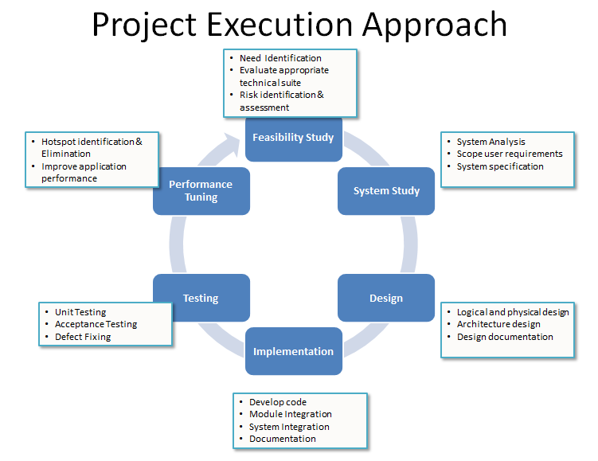Responsibilities of VERBAT team will be to prepare necessary documentation, establish development and test teams organize and execute developments/testing, and formulate the CR management process.

# 

# C:\Users\Prince\Downloads\Desktop\Untitled-2.pngDevelopment and Factory Acceptance

This phase of the delivery model will address the core development and factory testing of CLIENT application. This will be transitioned from the existing vendors into a single window where in CLIENT Group applications will be more reliable, migrating into a single source repository, more elaborate same fashion testing framework for the multiple applications and dependable disaster recovery through VERBAT multiple location presence. We are proposing CLIENT team’s involvement in consulting engagement for this phase. The implementation of the delivery model will consider more visibility into macro/micro management of the development and factory acceptance testing phase.

VERBAT will leverage its experience and knowledge on process capabilities to ensure high quality delivery and support. VERBAT will also engage its support group of experts on a constant consulting basis to address the shortfalls over the five years.

Responsibilities of CLIENT team will be very lean for this phase. VERBAT will be responsible for all development and factory testing of CLIENT applications. VERBAT welcome CLIENT team travelling to offshore to be part of the Factory Acceptance testing phase. This will ensure proactive risk reduction in delivery.

Responsibilities of VERBAT team will be to develop test and document source code, project management of the larger phase, testing co-ordination between off site and on site, maintaining the single source repository, maintaining the test database, and ensure quality delivery.

# Service Delivery Model

C:\Users\Prince\Downloads\Desktop\Untitled-2.pngIn our response, we propose to develop a new generation web application developing starting from the scratch.

In the proposed new service model we are trying to achieve the following goals

* Mitigate the risk involved in transition at various phases
* Transition into a single window solution provider for end to end CLIENT integration
* Reduce time to market of new developments by a flexible resource model
* Evolve a service model which will consider the existing CLIENT team to be merged with the proposed team structure
* Achieve more cost effectiveness by resource sharing and streamlining
* Delivery model to address all phases of application development from requirements, development, testing and implementation to infrastructure support
* Address the application roadmap (wish list)
* Address the future requirements, technology migrations, platform support, domain expertise requirements and effective expense management for the next five years
* Address the critical non-functional requirements
* KPI management of CLIENT project phases

VERBAT is proposing a transition vendor maturing to a steady state service delivery model. To mitigate the risks involved VERBAT will conduct a 1-2 months development and transition, which will be run under multiple stages with concrete delivery phases.

The scope of the current chapter is to describe the Service Delivery Model which will address the steady state period. The model will evolve during the transition phase and will be tailored to address the specific challenges of CLIENT Group applications. VERBAT has been successful in the past and continues to provide support for large industry players in safe transition of group applications to a single window provider concept. We have incorporated our past learning into the proposed delivery model and are also willing to attach expert group services to strengthen the delivery model over next five years.

# C:\Users\Prince\Downloads\Desktop\Untitled-2.pngKey Differentiators

Quality Assurance & Testing

Proven Methodologies & Processes

Investment in R & D

Strong Local Presence

Flexible commercial Models

Technology Associations

Software Development Experience

Offshore Development Centre

Delivered digital transformation expertise to global customers for over a decade by following industry best practices to maximize ROI for client

Keen technology intelligence combined with aggressive market research to deliver solutions that achieve results with measurable value

Enable access to global consulting expertise with strong local market and business knowledge

Commercial Model that is customizable for your business needs

Services that are designed to optimize applications for improved performance and overall efficiency

1,000,000 plus man-hours of expertise in technology frameworks spanning Microsoft, Open Source, mobility platforms and other proprietary IT technology

Partners top technology vendors to bring in the latest and best services in integration, collaboration, and development

Commercial Model that is customizable for your business needs

# C:\Users\Prince\Downloads\Desktop\Untitled-2.pngProject Governance Responsibility Table

|  |  |  |  |  |
| --- | --- | --- | --- | --- |
| Board Name | Head | Members | Responsibilities | Frequency |
| Steering Committee | CLIENT Senior Management representative | CLIENT Senior Management members,  VERBAT Senior Management members,  CLIENT Working Group representative,  VERBAT Account manager | * Revenue goals setting * Business strategy * Compliance management * Risk governance * Financial management * Asset management * Target setting for new opportunities * Budget guidance and approval | Quarterly/  On demand basis |
| Program Management Office | CLIENT group head | Program Manager, VERBAT onsite Program Manager, VERBAT offshore Program Manager | * Manage the project scope and change requests * Long term risk analysis * Budget approval | Monthly |

# C:\Users\Prince\Downloads\Desktop\Untitled-2.pngRoles and Responsibilities

|  |  |  |
| --- | --- | --- |
| Responsibilities of CLIENT staff | Phase | Roles |
| Elicitation of Requirements | Requirements | CLIENT Project Manager, CLIENT SME’s |
| Requirements Clarifications | Requirements | CLIENT Project Manager, CLIENT SME’s |
| Requirements Review | Requirements | CLIENT Project Manager, CLIENT SME’s |
| Requirements Approval and Signoff | Requirements | CLIENT Project Manager |
| Preparation of Acceptance Test Cases | Design | CLIENT Project Manager, CLIENT SME’s |
| Providing Master data for application setup | Development | CLIENT Project Manager |
| Hardware and Software Infrastructure required for deploying and testing the application | Development | CLIENT Project Manager |
| Connection to external systems | Implementation | CLIENT Project Manager |
| Availability of CLIENT Resources for UAT | UAT | CLIENT Project Manager |
| UAT | UAT | CLIENT Project Manager |
| Software Acceptance | Implementation | CLIENT Project Manager |
| Hardware and Software Infrastructure for production deployment | Implementation | CLIENT Project Manager |

|  |  |  |
| --- | --- | --- |
| Roles | Responsibilities | No. of Resources |
| CLIENT Senior Management | * Participate in Steering Committee meetings * Provide overall direction for the program execution | NA |
| CLIENT Group Head | * Oversee and direct the CLIENT program * Responsible for the overall CLIENT program | 1 – On CLIENT roles |
| CLIENT Working Group | * Core group of influence for KPI settings for project phases, support, testing, maintenance and helpdesk * Single point of contact for customer CLIENT * Formulate change requests * Organize and execute tests and trainings with CLIENT * Classify issues reported * Coordinate with business and decide the time frame for information of new releases and IT maintenance activities * First point of contact for all business issues | 1 – On CLIENT roles |
| VERBAT Account Manager | * Core group of influence for KPI settings for project phases * Manage relationship with CLIENT and take proactive steps to ensure their satisfaction * Participates in Steering Committee meetings | Non-Charged |
| VERBAT Region Delivery Head | * Manage escalations from customers, at a first-level * Ensure support for onsite project team | Non-Charged |
| VERBAT Service Delivery Unit Head | * Provide the strategic direction for the engagement * Manage resources ramp-up/down * Interactions periodically with CLIENT senior management * Handle any escalations that cannot be resolved by Program Manager/Project Manager | Non-Charged |
| VERBAT Onshore Program Manager (optional) | * Core group of influence for KPI settings for project phases, support, testing, maintenance and helpdesk * Oversee and direct the strategic engagement plan with CLIENT * Work with CLIENT and Offshore Team to identify the technical approach to be used and the deliverables to be furnished at the completion of the project * Guide Offshore Project Manager on overall program management goals * Responsible for delivering within acceptable KPI values | 1 |
| VERBAT Offshore Project Manager | * Establish and evaluate development policies, methodologies, and procedures * Project Management on all offshore activities * Work closely with onsite team in understanding the requirements and technical details of the projects * Responsible for the execution of project milestones and quality of project deliverables * Responsible for delivering within acceptable KPI values | 1 |
| Domain Experts | * Perform market study and suggest latest trends/best practices followed in the industry * Define road map for CLIENT by prioritizing the suggested features | 1 (50%) |
| Business Consultants | * Work closely with the CLIENT team in understanding the functional requirements of the new system * Develop requirements specifications and test cases based on the project needs * Support Production Support and development teams in providing necessary requirements clarifications during the design and development phases * Participate in functional testing of the application based on documented test cases * Ownership of the core product domain knowledge and also responsible for impact analysis in case of change requests | 1 (50%) |
| Offshore Program Manager | * Provide on-going corporate guidance and direction to the CLIENT team * Approve the Project schedule * Communicate project goals to all management levels * Provide appropriate and timely resources for efficient and effective project completion * Ensure sustained adherence to schedule commitments | 1 (50%) |
| Production Support (offshore) | * Provide Level 2 maintenance support * Resolve incidents * Service level tracking * Release management | 1 (50%) |
| Design/Development | * Implement Wish list items – design, development, testing * Functional testing of the application based on documented test cases * Prepare Test Report and Test logs * Defect reporting * Participate in defect analysis * Perform Non-functional testing | 3 |
| Testing team | * Perform onsite testing support during planned releases * Setup and maintain test environment * Maintain test data and migration strategies * Maintain configuration control database * Offshore release planning and release co-ordination | 1 |

# C:\Users\Prince\Downloads\Desktop\Untitled-2.pngInformation on Training (Training to Trainers)

## Training strategy

Once a system has been stabilized through adequate testing, the SDLC ensures that proper training on the system is performed or documented before transitioning the system to its support staff i.e Trainer.

Training usually covers operational training for those people who will be responsible for supporting the system in turn the trainer will be providing training for those end users who will be using the system after its delivery to a production operating environment.

After training has been successfully completed, systems engineers and developers transition the system to its final production environment, where it is intended to be used by its end users and supported by its support and operations staff.

## Plan

An important element in creating your training plan is to [evaluate the technical skill level(s)](http://www.techrepublic.com/5138-1035-729008.html) of those who will actually support the software. Some software, such as a new desktop operating system, may be rolled out throughout your entire organization. Some application programs may be installed only in a particular department (such as accounting software in the finance department or illustration software in the graphic design department) or only made available to employees with specific roles (for example, secretaries or department heads).

In many cases, software end-users are not particularly technically savvy, but you may have different technical skill levels within a group. It’s important in that case to provide different levels of training. Technical novices will need more focused, step-by-step instruction in basics, whereas more skilled computer users will quickly pick up the basics and benefit from more training that shows them how to use more obscure or advanced features of the software. Attempting to train the two groups together will result in the novices being overwhelmed and confused and the more skilled users wasting time that could have been spent doing their work.

## Training delivery methods

The next step is to assess methods of delivering the necessary training. Again, there are several factors to take into consideration:

* User skill levels as determined by your needs assessment
* Number of users to be trained
* Timeframe for rollout of the software (and whether you’ll be doing it in phases or throughout the entire organization at once)

There are several different methods for delivering training, and you may want to use a combination of these, especially in a large organization. The least effective is, unfortunately, the one used by most small organizations and many larger ones: the IT equivalent of throwing the kid in the water and letting him sink or swim. Suddenly the new OS or application appears on the end-user’s computer, perhaps with a copy of the manual, and it’s up to the user to figure it out and the company’s IT support desk to untangle the messes the user gets into. Some better training methods include:

* Individual hands-on instructor--An instructor walks each user individually through the process of performing common tasks and answers questions. This is the most expensive method, although potentially the most effective.
* Hands-on classroom style instructor-led training--An instructor shows users how the software works and how to perform common tasks, with users performing the tasks themselves in a classroom/lab setting. Each user or pair of users has a computer on which to practice. Classes of 15 to 30 are often effective.
* Seminar style group demonstration--An instructor shows users how the software works and how to perform common tasks in a live demonstration. Groups of 20 to 50 are often effective.
* Computer Based Training (CBT)--CD-based or online (Web-based) self-paced training which allows end-users to complete interactive lessons that walk them through the processes of performing common tasks, and the software tests them on their performance and understanding.
* Book-based self-paced training--End-users complete workbook lessons in how to perform common tasks, often illustrated with screenshots.

## Train the Trainer:

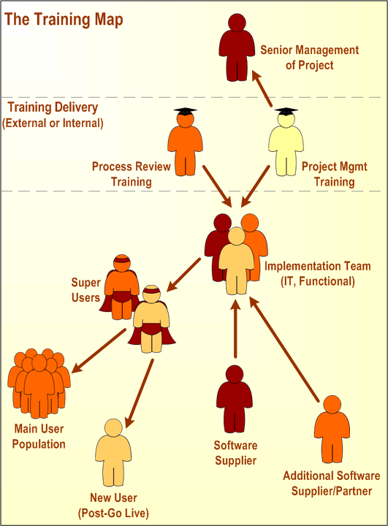We propose ‘Train the Trainer’ strategy, which is to give the proposed SME/Expert/Process Owner the skills to teach other people. A Train the Trainer module is a prepared learning experience to provide the information to be taught and to give a prospective trainer the experience of teaching the material before "going live." Many companies are very specific on how they want their employees trained-- for example, the information, time allotted for class and evaluation scores--and so preparing the trainer

makes sense.

## Creating a training program

End-user training is more effective and memorable if you tailor it to your own organization's use of the software, rather than generic lessons. For example, Microsoft Word instruction should include examples of actual templates that your users will be using for their documents. Some elements of your lesson plan should include:

* The purpose of the software.
* Tasks the user will complete with the software
* How it differs from previous versions or products it’s replacing (if applicable)
* Common problems users may encounter
* Security issues related to the software

# C:\Users\Prince\Downloads\Desktop\Untitled-2.pngResponsibilities

## VERBAT

* Provide details on the required infrastructure needed to deploy the product and solution for the POC
* Create and develop the solution as described in the Scope
* Deploy the product and solution in the infrastructure at the Customer facility remotely.
* Provide timely support to Customer during the execution phase

## CLIENT

* Provide details on the file types and samples for template design
* Provide clarifications to VERBAT on the various devices and its configurations
* Provide clarifications to VERBAT on the special requirements
* Make the on premises infrastructure available to VERBAT with minimum server specification as indicated below.

|  |
| --- |
| Recommended configuration – one machine |
| **Processor:** 2 x Intel Xeon 2GHz 4 CPU core |
| **Memory:** 16 GB |
| **HDD:** 1TB |
| **Operating system:** Windows Server 2008/2008R2 x64 Standard Edition (Enterprise Edition is needed to use sql failover clusters) |
| **Web server:** IIS7.5 |
| **SQL server:** Microsoft SQL Server 2008/2008R2 x64 |

* Make the infrastructure and resources available to deploy the product and solution.

# Team communication structure

C:\Users\Prince\Downloads\Desktop\Untitled-2.pngFollowing is the team that will be involved during the POC:

|  |  |
| --- | --- |
| **Customer** | **Vendor** |
| Business Sponsor | Technical & Migration |
| Business Coordinator |  |
| Technical Leads |  |
| Infrastructure Support |  |

# 

# C:\Users\Prince\Downloads\Desktop\Untitled-2.png Acceptance Criteria

For the purposes of this project, the criteria used for acceptance of the project are:

* VERBAT solution operates with the hardware and software with which it is designed to operate and corresponding reports are produced
* VERBAT solution meets all the functionalities defined under the scope
* The deliverables stated in RFQ are fulfilled

# C:\Users\Prince\Downloads\Desktop\Untitled-2.png Service & Maintenance

## Service Options Available

There are 3 tier of service levels. The first level is through email support in which queries are sent and responses are also via return email. The second level is through our service hotline where our support staff will respond through telephone. The third level is on site support which is on basis.

## Response Times

Service level is dependent on whether Customer is a maintenance contract customer. Priority is given to maintenance contract customers. For minor problems, the response is within the next working day of 24 hours. Minor problems in context refer to problems that can be solved by email or over the telephone hotline. For major problems, response time can be up to 4 hours upon notification and can be on site (which is chargeable). The average response time is therefore dependent on whether it is classified as minor or major problem. The average response time of problem resolution cannot be quantified because it is dependent on the nature of problem i.e. whether it is a design problem or bugs that required rectification at principal level. However, if problems are of process design, problem resolution can be relatively fast, usually from statistics, it is within 24 to 48 hours.

## Support Service Level Options Available

As part of our proposal VERBAT provides 3 tiers of service levels:

|  |  |
| --- | --- |
| **Service Level** | **Services Provided** |
| 1st Level | Through email support in which queries are sent and responses are also via return email. |
| 2nd Level | Through our service hotline where our support staff will respond through Skype. |
| 3rd Level | In the event if the first two levels could not rectify the problem, onsite support will be provided, which will be chargeable. |

**Severity Levels**

The table below outlines the different severity levels of service requests, the recommended method of contact for each severity level and the associated targeted initial response time. These response times apply to all support requests submitted. In the case of a 9x5 working hour the response time is measured only within normal support hours.

|  |  |  |  |
| --- | --- | --- | --- |
| **Severity Level** | **Description** | **Recommended Contact Method** | **Response Times** |
| **Critical** | System is inoperable, not functioning; data is lost or Business outage or significant impact threatening productivity. | Phone | 30 minutes |
| **High** | Problem impact is high; production is proceeding but in an impaired fashion. Workarounds are available. | Phone or E-Mail or Web | 4 Hours |
| **Normal** | Issue does not have significant current productivity impact. Examples: product enhancements, usage questions, and cosmetic problems. | E-Mail or Web | 8 hours |

**Our Support Days**

Monday to Friday

# C:\Users\Prince\Downloads\Desktop\Untitled-2.pngEscalation Process

There are at least 2 escalation levels of which the first level is at the project manager’s attention. If the project manager cannot resolve the problem at hand, it will be further escalated to VERBAT’s management. VERBAT’s management will carry out a problem analysis to deploy further resources to resolve the issue on hand.

# Warranty

VERBAT provides 3 months of warranty of service from the date of system “go live” based on the products and service delivered (excluding hardware, if any, which will be based on hardware warranty period defined). The service warranty is based on the process design and bugs fixes for the process.

Beyond the 3 months’ warranty, the project still can be covered under AMC contract.

Year-1 to year-5 shall cover 28 hours per year of maintenance support. The hours does not include any enhancements. Any additional hours shall be chargeable on an hourly rate based on time and materials.

# C:\Users\Prince\Downloads\Desktop\Untitled-2.pngHigh Level Project Plan

Estimated start date: To be given once tender awarded.

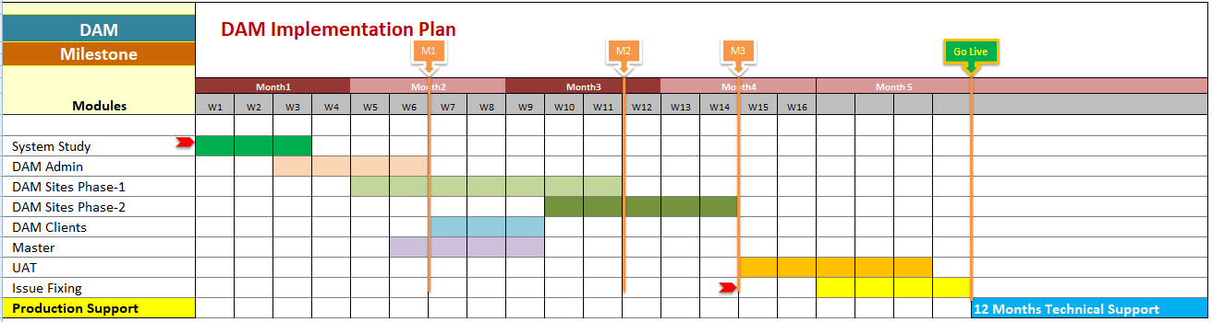

# C:\Users\Prince\Downloads\Desktop\Untitled-2.pngProject Costing

|  |  |  |  |
| --- | --- | --- | --- |
| **Line Number** | **Quantity** | **Unit of Measure** | **Unit Price (in USD)** |
| **0001** | 1.000 | each | 45256 |
| **Product Catg.:** Digital Asset Management Software | | | |
| **Item Description:** Digital Asset Management Software licenses | | | |
| **Tendering Text:** Enter the price for one license as specified in Section Scope of Work. The price must includeonsite or remote vendor installation including the one year of maintenance and managed service support in addition to all other requirements listed in the Scope of Work. | | | |

|  |  |  |  |
| --- | --- | --- | --- |
| **Line Number** | **Quantity** | **Unit of Measure** | **Unit Price (in USD)** |
| **0002** | 3.000 | Years | 20160 |
| **Product Catg.:** Warranty Support | | | |
| **Item Description:** 3 years Warranty Support | | | |
| **Tendering Text:** Enter the price for the 3 year of warranty support as specified in Section Scope ofWork | | | |

# C:\Users\Prince\Downloads\Desktop\Untitled-2.pngPayment Terms

All customer payments shall be made within 15 days from the date of customer raising the invoice by transferring the funds into the customer bank account detailed below.

* 30% advance along with signing of this agreement
* 25% Milestone-2
* 25% Milestone-3
* 20% on Go Live & before deploying the application to production server
* Yearly AMC payment needs to be paid upfront within 15 days from the starting of AMC period.

# C:\Users\Prince\Downloads\Desktop\Untitled-2.pngWhat’s Next?

Once you send us confirmation of this project by email, we can start documentation for Project Contract and move on.



3

2

1

**Selection and PO to kick off the project.**

**We Study the Requirement and furnish you the Proposal.**

**RFQ out for vendor response.**



**Deal!**1. We sign contract and non-disclosure agreement.  
2. We schedule start date and resources mobilisation.  
3. You make initial payment.



4



**Project Starts!**

# Other Tools and Technologies

C:\Users\Prince\Downloads\Desktop\Untitled-2.pngOne of the major concerns about off-shoring is the lack of communication between the stakeholders and the engineering team. This was overlooked by many of the off- shore development teams and has often led to stakeholders looking for other teams who can better understand their requirements. VERBAT, being a leader in application development wants to have contented customers who are fully satisfied with the results.

In an effort to ensure this we have implemented a few processes within the organization to ensure effective utilization of the team and thereby provide value-for-money to the stakeholders. We use the following tools and methodologies on every business we work with.

* We use Confluence (http://www.atlassian.com/software/confluence/ ) as the knowledge base.
* We use Jira (http://www.atlassian.com/software/jira/ ) to know the heartbeat of every project.
* We use Github (http://github.com/) as our source code repository
* We use Hudson (http://hudson-ci.org/) as our Continuous Integration server
* We use agile development and extreme programming
* We do short-iterations to save features from drifting out of control
* We use simple point-based system for story estimation
* We do test-driven development
* We do sprint planning and daily huddle meetings with the team.
* Retrospective meeting with engineering team after every testing cycle.

Confluence is like an enterprising collaborative space which acts like Wiki where we can store documents and information and also share them among the people we want. All the project requirements including drawings / sketches will be uploaded here and this will dole out as a “One Stop Shop” to see everything about the project. We have also implemented role-based security policies to ensure that these documents can only be viewed by authorized logins.

# C:\Users\Prince\Downloads\Desktop\Untitled-2.pngCOTS/Software components/Others

|  |  |  |  |  |
| --- | --- | --- | --- | --- |
|  |  |  |  |  |
|  | **Sl No.** | **Technology/COTS** | **Used for** |  |
|  | 1 | Microsoft .Net | Custom Development |  |
|  | 2 | Microsoft Sharepoint Foundation | Base CRMS |  |
|  | 3 | Microsoft Sharepoint Server | Deployment server |  |
|  | 4 | Microsoft Visual Studio | Development platform |  |
|  | 5 | Microsoft Team server | Continuous integration |  |
|  | 6 | Microsoft Word | Integration |  |
|  | 7 | Microsoft Excel | Integration |  |
|  | 8 | Microsoft Pover pivot | Integration |  |
|  | 9 | Microsoft SQL Server | Database server |  |

# C:\Users\Prince\Downloads\Desktop\Untitled-2.pngContact Details

**Phone**: +91 8129 77 44 00 Ayyam Perumal   
**Email**: [ayyam.perumal@verbat.in](mailto:ayyam.perumal@starnex.in)

END OF DOCUMENT